

CANKAYA UNIVERSITY
FACULTY OF ENGINEERING
COMPUTER ENGINEERING DEPARTMENT

Project Report
Version 1

CENG 407
Innovative System Design and Development I

An SaaS Platform for Ridesharing, Taxi Cab, Food Delivery and Shipping

Onur Dündar YALDIR
201411066
Onur Ata Sarıtaş
201511049
Alper Odaman
201511042

Abstract 2
1. Introduction 2
1.1 Problem and Solution 2
1.2 Motivations 3
2. Literature Review 3
2.1 Background 3
2.2 Related Literature 3
3. Summary 4
3.1 Final Thoughts 4
4.Software Requirement Spesifications 5
4.2 Overall Description 5
4.2.1 System Environment 5
4.2.2 Users 5
4.2.3 Operating Environment 6
4.3 External Interfaces 6
4.3.1 User Interfaces 6
4.3.2 Hardware Interfaces 6
4.3.3 Software Interfaces 6
4.4 System Features 6
4.4.1 Functional Requirements 6
4.4.2 Performance Requirements 12
4.4.3 Security Requirements 12
4.4.4 Software Quality Attributes 12
5. Software Design Description 13
5.1. Introduction 13
5.1.1 Purpose 13
5.1.2 Scope of this Project 13
5.1.3 Glossary 13
5.2 Architecture Design 14
5.2.1 Class Diagram 14
5.2.2 Interface for Passengers 14
5.2.3 Interface for Drivers 16
5.2.4 Activity Diagram 17
5.3 Use Case Realizations 18
5.3.1 Components of Mobile Application 18
6. Conclusion 19
References 19

Abstract
With the widespread popularity of smartphones, several applications regarding commuting inside cities and traveling has been introduced. In this paper, we have reviewed several ideas regarding ride sharing applications, its effects on environment, how it’d work with recent vehicle routing algorithms, its ease of use with mobile and online payment systems and its reliability as an SaaS platform.
KEY WORDS: Peer-to-peer ridesharing, software-as-a-service platform, mobile application development.

1. Introduction

1.1 Problem and Solution
Peer-to-peer ridesharing is a growing area of transportation that has gained popularity with the widespread usage of smartphones and online payment systems. After World War II, ridesharing idea started as “car-sharing clubs” in America, with government supports regarding workplace and regulations, alternative transportation and commuting methods surfaced. In early 1990’s these alternative methods such as ridesharing didn’t gain much popularity, caused by drivers’ and passengers’ communication problems, drivers’ unsafe driving habits, and issues regarding payment. Recent technological advancements in IT fields made these issues irrelevant, smartphones and online platforms are tools most people use almost constantly. Several companies has made use of this vacancy in transportation methods, and peer-to-peer ridesharing applications grew in popularity. These applications removes communication issues between drivers’ and passengers’, using cutting-edge algorithms for vehicle routing and passenger stops they provide optimized routes and solves disputes with their feedback systems and mobile payment options.

1.2 Motivations
As discussed in Literature Review, ridesharing is a growing area of transportation that has gained popularity with the widespread usage of smartphones and online payment systems. Several companies has made use of this vacancy in transportation methods. These applications removes communication issues between drivers’ and passengers’, using cutting-edge algorithms for vehicle routing and passenger stops they provide optimized routes and solves disputes with their feedback systems and mobile payment options.

2. Literature Review

2.1 Background
Ridesharing typically involves carpooling, which is gathering several travellers into private automobile. Most automobiles can carry at least four passengers, however the rate of car occupancy continues to decline [1]. Most recent data for average number of passengers per car for the countries sampled in a research done by European Environment Agency in 2016 is approximately 1.45 passengers per vehicle [2]. There are many benefits in ridesharing since it reduces the amount of vehicles needed by travellers such as reduced energy consumption, greenhouse gas emissions, parking space needed and traffic congestion. According to a case study done by Fox Networks Group for The Rideshare Company, ridesharing has been used to avoid 1,770,585 vehicle trips, 18,254,291 lbs. of CO2 emissions and 924,184 gallons of gas ended up being saved [3]. The sheer magnitude of these numbers show that ridesharing is an activity that can be used as an efficient transportation alternative. The strictness of common ridesharing engagements, creates a difficulty for people to engage in these activities. However advancements in information technologies allows passengers and drivers to gather round with no serious commitments and little premeditation. Lately ridesharing also involves more unique forms like peer-to-peer ridesharing or sometimes called dynamic ridesharing. Dynamic ridesharing presents people convenience and flexibility. Travelers can request rides minutes before their desired departure times while advances in GPS technology assists drivers in finding routes, which in return increase the convenience of both parties. However, bringing together ridesharing activities such as Food Delivery, Shipping and Taxi Cab in a single platform is a tall task, traffic congestion and general transportation methods should be considered. Traffic congestion manifests itself in cities mostly during and after morning commutes and rush hours in business areas. Increased traffic density causes escalated commute times, extra oil consumption, environmental pollution and many more unfavourable effects. Ridesharing is a means to address these risk factors, and is considered as an alternative to public transportation to traffic congestion[4][5]. More recently, with technological advances in GPS technology and innovational ride sharing initiatives such as Uber, Lyft and Carma; ridesharing market is growing steadily.

2.2 Related Literature

The online delivery of software, sometimes called Software As A Service; is a software distribution model where the hosting and management of an application is handled by a third-party provider. This distribution model removes the need for organizations to install and run applications on their own. Software As A Service (abv. SaaS) has become a common delivery model for many business applications, such as office software, management software, development software, accounting etc. The advantage for using third-party providers for these services, is reducing development times since there’s no reinventing the wheel, developers use already existing solutions to their problems and implement them into the project. This process creates more reliable products, troubleshooting bugs and errors is less troublesome compared to traditional development methods. This model of delivery is being used for ridesharing applications such as Uber[6][7], using Google Maps API and Mapbox API for geolocation and payment options such as PayPal, Google Wallet and Apple Pay. Online payment is a controversial topic since most people aren’t very trusting about electronic payment schemes. However, today, online payment is the fastest and most reliable way of paying for services and products since the transaction happens virtually, there is less chance of fraud, realistically there is no human error involved. SaaS platforms uses third-party providers for transactions, making the entire platform secure by design. These transactions’ fast nature is generally combined with mobile payments. Payments in mobile platforms can be done with smartphones, tablets, or generally Near Field Communication (abv. NFC) devices. These mobile devices is used to authorize and exchange money for services on the go, making them essentially the best choice for ridesharing applications. The wide usage of smartphones and mobile payment gave peer-to-peer ridesharing popularity a boost. SaaS platforms offers mobile applications quicker deployment times for new features and easy updates for existing ones. There are substantial amount of benefits using SaaS platforms. For developers, using SaaS platforms reduces risks in security; third party components can provide reliable security for developers not well-versed in handling sensitive data. Third party components can also assist teams in staying up-to-date.
One of the most important systems in mobile applications is the feedback system. In traditional web and mobile applications, feedback systems can be grouped into 2 main groups. These are direct and indirect feedback systems. Direct feedback systems ask the user directly about the application with their opinions and experiences with question surveys or pop-ups. Indirect feedback systems aim at creating meaningful feedback by processing the user's history of use on the system, the frequency of clicks in the system. The aim of feedback systems is to identify product holders, designers and developers with problems, shortcomings and situations in which the end user is not satisfied. The feedback system allows the system or application to be a more successful product with feedback from users.

3. Summary

3.1 Final Thoughts

Nowadays, the use of some software services has become popular in order to facilitate people's daily lives or to gain extra economic benefits. One of them, the ridesharing system, provides safe and more economical journeys without time constraints. Considering the problems of some of ridesharing schemes used in the 1990s, the modern-day versions of ridesharing has been developed from the ground up by using innovative technologies. However, there are some technologies that people hesitate to use, like mobile payment. However, after realizing the reliability of these technologies, there is no doubt that ridesharing will become much more advanced than where it is now and that it will be used not only in developed countries but in many places around the world. One of the factors that make ridesharing safe is the evaluation of passengers and drivers with feedbacks and rating system. In this way, both drivers and passengers can make their choices by seeing the average score.

4.Software Requirement Specifications

List of Figures
- Figure 1: Menu Use Case Diagram
- Figure 2: Main Menu Use Case Diagram
- Figure 3: Driver Use Case Diagram

4.1 Introduction
4.1.1 Purpose

The purpose of this document is to describe the project called An Saas Platform for Ridesharing Taxi Cab, Food Delivery and Shipping. The project aims to reduce travel time and traffic problem via mobile platform. The mobile platform uses the feedback system to rank passengers and drivers, reduce risk factors and provide a safer and cheaper way to travel. This document contains detailed information about the requirements of the project. Reflect the defined restrictions and recommended software functions. The SRS document also describes how drivers and passengers interact.

4.2 Overall Description

4.2.1 System Environment

This application is a dynamic ridesharing and carpooling application. The user which can be passenger, driver or both. Passenger calls a driver which passenger can select and driver accept passenger for a drive. Users can give feedback to each other users. For drivers the system should confirm the driver’s licence.

4.2.2 Users
4.3.2.1 Passengers

Passengers must have a smartphone.

Passengers must know how to use applications.

Passengers must know how to use wallet systems.

Passengers must know at English at least initial level.

4.2.2.2 Drivers
- Drivers must have a driver license.
- Drivers must have a smartphone.
- Drivers must know how to use applications.
- Drivers must know how to use wallet systems.
- Drivers must be never get a traffic ticket for drink and drive.
- Drivers must never suspended from system before.

4.2.3 Operating Environment
This system will be a web application. So that it can be used every browser. Only internet connection and an updated (for performance) browser needed.On the database side, a database system will be used to design and implement the necessary entities, tables and relations. . Web applications are flexible and has proven performance. Only with a front-end development it can be a mobile application. End of the project system will be a mobile application that is based on web application.

4.3 External Interfaces

4.3.1 User Interfaces
- A smart phone or a browser include menus like call drive, my wallet, login, logout, sign up also drivers can navigate these menus but drivers will have extra operations

4.3.2 Hardware Interfaces
- This project requires a server for server-side operations, databases etc

4.3.3 Software Interfaces
- This project requires a internet connection for APIs' and external map APIs, and a database connection for read/write data.

4.4 System Features

4.4.1 Functional Requirements

4.4.1.1 Starting Menu
- Login
- Sign Up
- Sign Up with License
- Log Out
4.1.1.1.1 Description
- Sign Up : User must sign up before login
- Sign Up With Licence : Users must Sign up With Licence for being a driver.
- Login : User must login before perform any operations.
- Log out : User must log out after no need to use this application.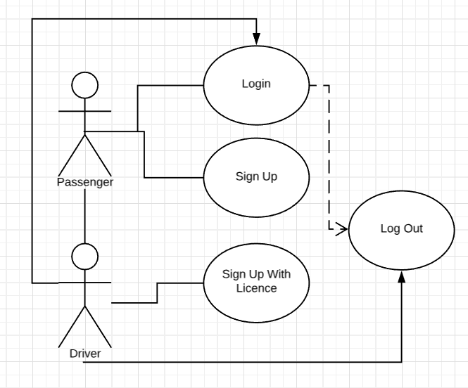
4.1.1.1.2 Flow Description
1. Sign Up
1.1. User must sign Up with valid informations
1.1.1. If informations are invalid, error message is displayed.
2. Sign Up With Licence
2.1. User must sign up with Licence and valid informations if want to be a driver.
2.1.1. If informations are invalid, error message is displayed
2.2. The confirmation waiting from system for being a driver.
3. Login
3.1. After sign up user login the system using credentials which created in sign up step
3.1.1. If credentials are invalid, error message is displayed.
3.2. User redirected to main menu.
4. Log out
4.1. After using application. User log out from system

4.4.1.2 Main Menu
- Edit Profile
- Call for Drive
- Score Last Travel
- My Wallet
- Accept Drive
4.4.1.2.1 Description
- Edit Profile: Both passengers and drivers should be able to edit their profile.
- Call For Driver: Passengers call drive and select their drivers after that,they are making payment.
- Score Last Travel: Both passengers and drivers should be able to give feedback for their last travel.
- My wallet: Both passengers and drivers should be able to manage their wallet.
- Accept Drive: Only confirmed drivers can accept drives.
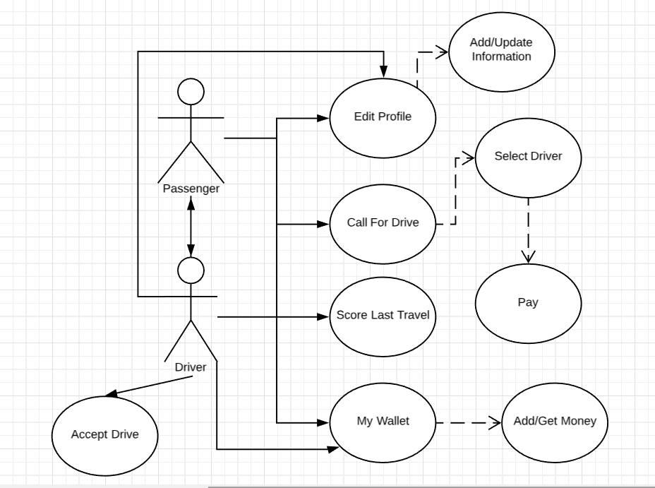

4.4.1.2.2 Flow Description
4.4.1.2.2.1 Passenger Side
1. My wallet
1.1. Passenger goes the My wallet section and add money first.
1.1.1. If there is an error. Message is displayed.
2. Edit Profile
2.1. Passenger goes Edit Profile Menu and Add Informations.
2.1.1. If there is an error. Message is displayed.
3. Call For a Drive
3.1. Passenger calls for a drive.
3.1.1. If there is an error. Message is displayed.
3.1.2. Passenger select the driver.
3.1.2.1. If there is an error. Message is displayed.
3.1.3. Passenger pay the payment.
3.1.3.1. If there is an error. Message is displayed.
4. Score Last Travel
4.1. Passenger goes score last travel section and gives feedback for last travel.
4.1.1. If there is an error. Message is displayed.
4.4.1.2.2.2 Driver Side
1. Edit Profile
1.1. Driver adds informations to profile.
1.1.1. If there is an error. Message is displayed.
2. Accept Drive
2.1. Driver accepts the drive
2.1.1. If there is an error. Message is displayed.
2.2. Driver provides the service.
3. My Wallet
3.1. Driver goes my wallet section and check money.
3.1.1. If there is an error. Message is displayed.

4.4.1.3 Driver Menu
- Preferences
- Service Preferences
- Drive History
- Give Feedback
- Current Travel
- Notifications
4.4.1.3.1 Description
Preferences: Drivers can be able to select in this screen, which services they will provide.
Drive History: Drivers can be able to list old drives from this screen and give feedback
Current Travel: Drivers can be able to access information about current travel like map, billing, navigation etc
Notifications: Drivers can be able to access old and new notifications like calling from any passenger, feedback notifications etc…
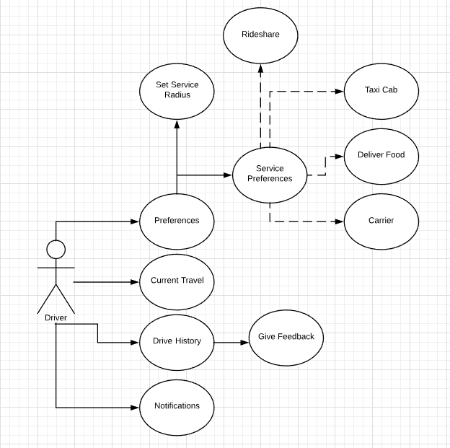
4.4.1.3.2 Flow Description
1. Preferences

1.1. Service Preferences
1.1.1. Set which services will be provide
1.1.1.1. If there is an error, message is displayed.

1.2. Set Service Radius
1.2.1. If there is an error, message is displayed.
2. Notifications
2.1. Check notifications regularly for if new passenger.
2.1.1. If there is an error, message is displayed.
2.2. Accept Passenger.
2.2.1. If there is an error, message is displayed.
3. Current Travel
3.1. Get the passenger,food or goods to transport.
3.1.1. If there is an error, message is displayed.
4. Drive History
4.1. List drives historically and get the information about.
4.1.1. If there is an error, message is displayed.
4.2. If feedbacks are missing, give feedback.
4.2.1. If there is an error, message is displayed.

4.4.2 Performance Requirements
The performance of connection between client and server must have high quality without any latency to avoid bad calls for drivers or passengers. Also API’s response speed which are finding routes, meeting drivers and passengers has importance. Transition between menus must be smooth and fast. Authentication module must be fast and reliable.

4.4.3 Security Requirements
The feedback & scoring system must be processed attentively for both passengers and drivers security. Also payment system must be a reliable and proven payment system.

4.4.4 Software Quality Attributes

4.4.4.1 Adaptability
- This project is also Software as a Service. Everyone can use this platform with specified roles.

4.4.4.2 Portability
- This project aims at smart phones.
- The project will be a web app, so it can be used every browser not just smartphones.

4.3.3 Usability
- There are 2 roles in this project.
- Passengers
- Drivers.

5. Software Design Description

List of Figures
Figure 1: Main Page Interface for Passenger Figure 2: Class Diagram Figure 3: Main Interface Flowchart for Drivers Figure 4: Activity Diagram for the Application Figure 5: Use Case Realizations of the System

5.1. Introduction

5.1.1 Purpose
The purpose of this document is to describe the implementation of the “Riders on the Storm: An SaaS Platform for Ridesharing, Taxi Cab, Food Delivery and Shipping” application described in the Project Proposal Document. The application is designed to be used in ridesharing, food delivery, shipping and taxi cab activities.

5.1.2 Scope of this Project
This document describes the implementation details of the Riders on the Storm application. The application will consist of 2 major parts. First part will be the application interface for mobile devices, this interface will consist of two parts, one for passengers, one for drivers. Second part is the server API for these interfaces mentioned above to communicate and coupling. This diagram also consists of Flow Chart Diagram, Class Diagram and Use Case Diagrams. Every figure serves the purpose of explaining design details.

5.1.3 Glossary
Terms | Definitions
API | A set of subroutine definitions, communication protocols, and tools for building software. [19]
SaaS (Software-as-a-Service) Platform | A software distribution model in which a third-party provider hosts applications and makes them available to customers over the Internet. [20]
Peer-to-peer Ridesharing | A service that arranges one-time shared rides on very short notice. [21]
Mobile Application | A computer program or software application designed to run on a mobile device such as a phone/tablet or watch. [22]
React Framework | A JavaScript library for building user interfaces.
React Native | A framework for building native apps using React Framework.

5.2 Architecture Design

5.2.1 Class Diagram
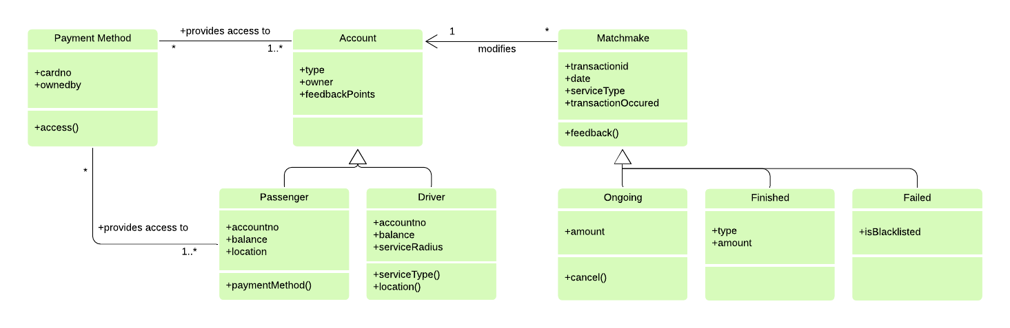

5.2.2 Interface for Passengers
Description: This main page is the logged in passenger’s home page. There is a local map, a button and there are two hyperlinks in this page. One of the hyperlinks connects menu page which has four hyperlinks and personal average feedback score which is given by drivers. First hyperlink brings passenger’s past travels. Second hyperlink connects to the help page. Third hyperlinks connects to passenger’s payment page. And the last hyperlink brings the settings page. The second hyperlink of main page connects to WHERE page. This page has one label and one hyperlink. The label brings other saved addresses. The hyperlink is to redirect client side and passenger select a location from local map. In the client side if passenger slip the local map a button comes up. This button shows the passenger’s current location.
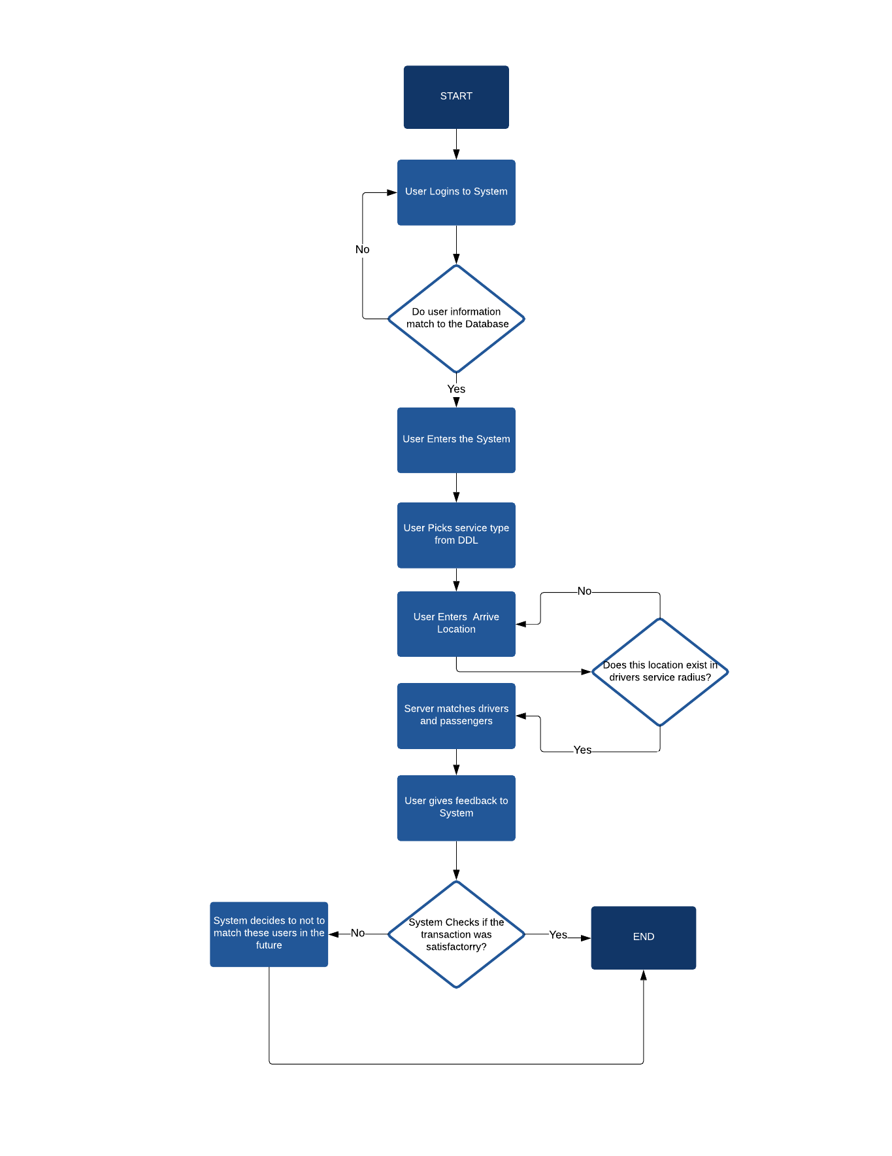

5.2.3 Interface for Drivers
Description: This main page is logged in driver’s home page. There are 4 hyperlinks for notifications for new passengers to accept and feedback notifications, a preferences hyperlink redirects a 2 new hyperlinks that redirects service preferences and set service status.Other hyperlinks in mainpage are drive history which is list old drives chronological and Current Travel hyperlink shows information about live travel session.
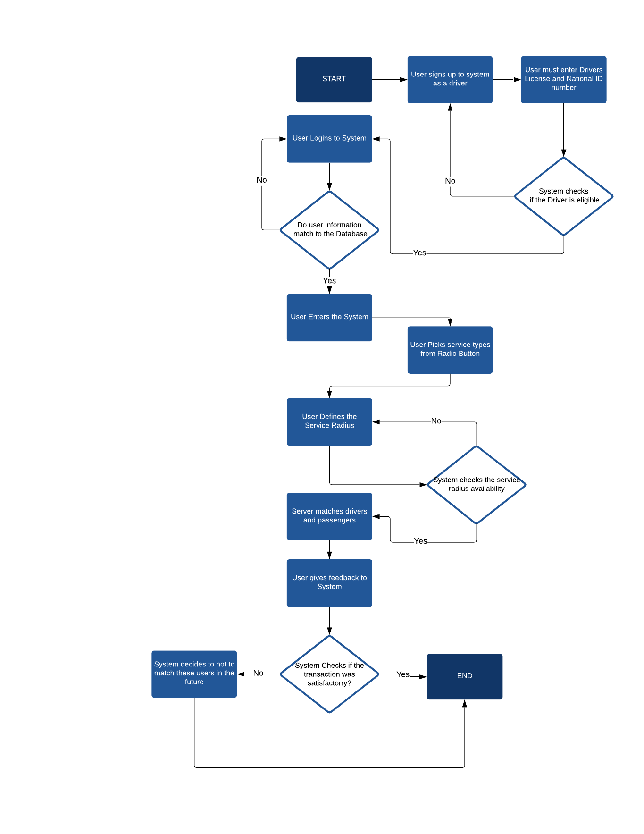

5.2.4 Activity Diagram
Activity Diagram describes the dynamic aspects of the system. First, Users should register to the system, giving their personal information. There are two options for registering, they can be drivers or passengers. After passenger is selected, the system should check the passenger information validity, if they are signed up before or not. After driver is selected, the system requires National Identification Number to check for traffic tickets for drinking and driving. After the security check the system pulls up the Main Interface respectively.
In Main Interface, Drivers should specify their preferences for their requested service types and service radius. The system pushes the driver to a queue and the driver is ready to go.
In Passenger side, Users picks their service type and arrive locations. After the system validates the arrive location for errors, the System matches drivers and passengers for the current process. Checks if the match is blacklisted, if not, match occurs. After the transaction happens, the system takes feedback from both parties, and decide to blacklist the match or not.
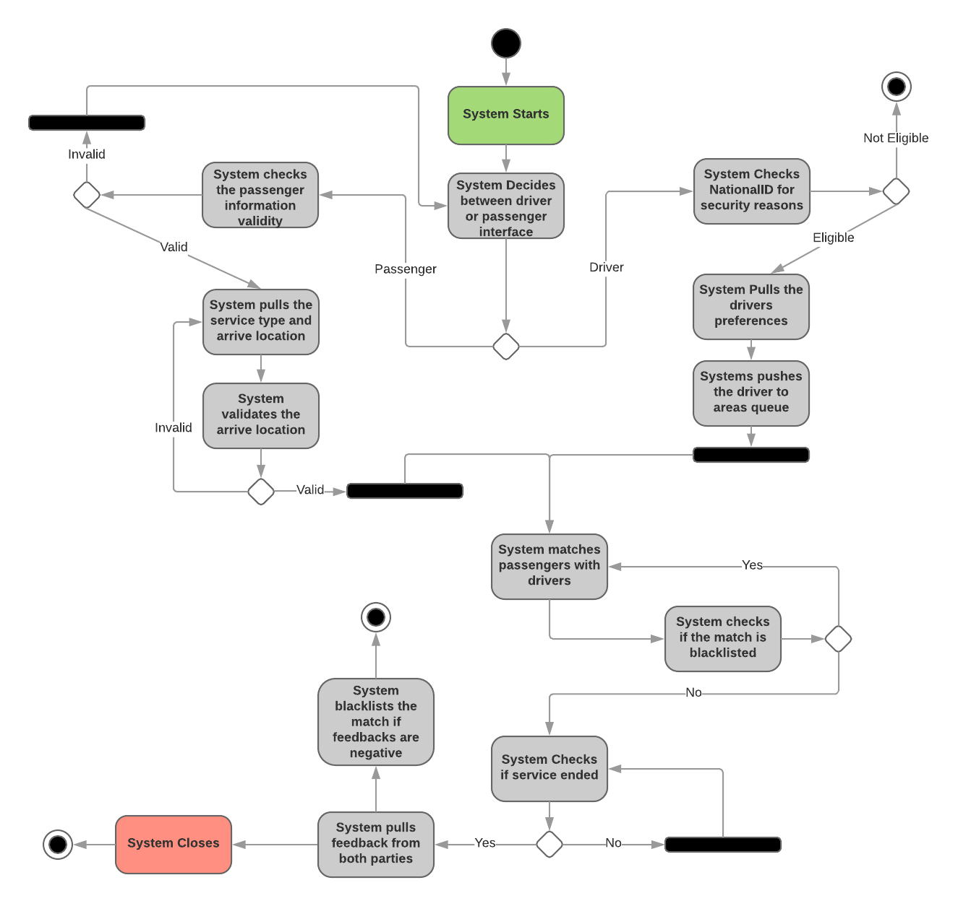

5.3 Use Case Realizations
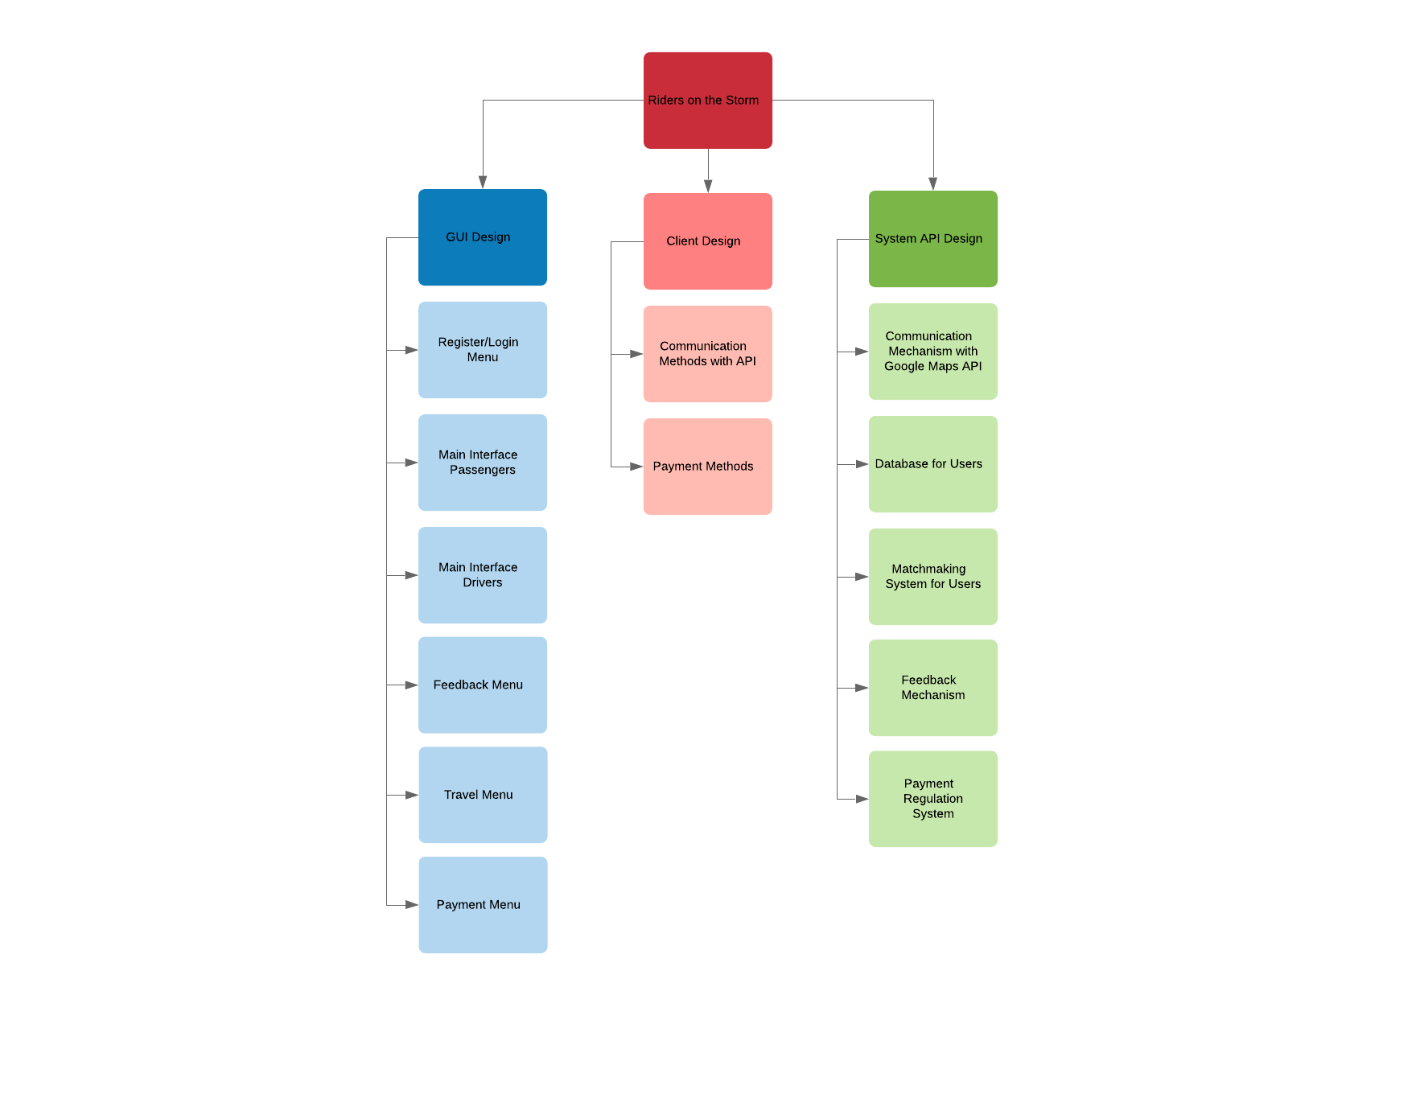

5.3.1 Components of Mobile Application
In the above Figure, the components of the application is demonstrated. The system consist of three major components, GUI Design, Client Design and System API Design.

5.3.1.1 GUI Design
The GUI Design focuses on making an interface with a focus on looks. It provides an interaction between the user and application. It is composed of Register/Login Menu, Interfaces for botw Passengers and Drivers, Feedback Menu, Travel Menu and Payment Menu. The User will start the application in Register/Login Menu, and continue onwards to the Main interfaces, and after transactions, Travel, Feedback and Payment Menus.

5.3.1.2 Client Design
The Client Design comprises of Communication and Payment methods. The Application should be able to communicate with the system's API, to handle location, match and feedback methods. Payment methods can be handled by third parties such as PayPal or Google Wallet.

5.3.1.3 System API Design
The System API Design is the core of the application. The system will handle all location and matchmaking systems, feedbacks and payment regulations. Also the system should handle the Users information in a database.

6. Conclusion
In this document we collected information about our project which named as “An SaaS Platform for Ridesharing, Taxi Cab, Food Delivery and Shipping”. This project mainly want to achieve to reduce commuting time, economic profit, ease the transportation for everyone. We decided to develop this project because there is no any example in our country and this sector is proven worldwide.

Our project requires real-time communication, real time gps information. We have researched a lot of technologies which other companies used for similar projects and tried to understand how it can be more efficient. We declared mistakes from past and we are going to try to not make these mistakes in our project.

References

- [1] Deakin, E., Frick, K. T., & Shively, K. (2012). Dynamic ridesharing.
- [2] Chan, N. D., & Shaheen, S. A. (2012). Ridesharing in north america: Past, present, and future. Transport Reviews, 32(1), 93-112.
- [3] Amey, A., Attanucci, J., & Mishalani, R. (2011). Real-time ridesharing: opportunities and challenges in using mobile phone technology to improve rideshare services. Transportation Research Record: Journal of the Transportation Research Board, (2217), 103-110.
- [4] Kelly, K.L., 2007. Casual carpooling-enhanced. J. Public Transp. 10, 119–130
- [5] Ferguson, E., 1997. The rise and fall of the American carpool: 1970–1990. Transportation 24, 349–376
- [6] Introducing a more flexible option to purchase the Google Maps Web Service APIs. (2018, November 01). Retrieved from https://mapsplatform.googleblog.com/2015/09/introducing-more-flexible-option-to.html
- [7] Uber Developers API (2018, November 01). Retrieved from https://developer.uber.com/docs/riders/ride-requests/tutorials/api/introduction
- [8] Qin, Z., Sun, J., Wahaballa, A., Zheng, W., Xiong, H., & Qin, Z. (2017). A secure and privacy-preserving mobile wallet with outsourced verification in cloud computing. Computer Standards & Interfaces, 54, 55-60.
- [9] Pernet-Lubrano, S. (2010). Mobile payments: moving towards a wallet in the cloud?.
- [11] Yang, Y., Liu, Y., Li, H., & Yu, B. (2015). Understanding perceived risks in mobile payment acceptance. Industrial Management & Data Systems, 115(2), 253-269.
- [12] Masoud, N., Nam, D., Yu, J., & Jayakrishnan, R. (2017). Promoting Peer-to-Peer Ridesharing Services as Transit System Feeders. Transportation Research Record: Journal of the Transportation Research Board, (2650), 74-83.
- [13] Bauer, D. (2017). Opportunities and barriers of ride-sharing in work commuting–a case study in Sweden.
- [14] Ma, R., & Zhang, H. M. (2017). The morning commute problem with ridesharing and dynamic parking charges. Transportation Research Part B: Methodological, 106, 345-374.
- [15] Masoud, N., Nam, D., Yu, J., & Jayakrishnan, R. (2017). Promoting Peer-to-Peer Ridesharing Services as Transit System Feeders. Transportation Research Record: Journal of the Transportation Research Board, (2650), 74-83.
- [16] Zickuhr, K. M. (2016). When Uber comes to town: The impact of transportation network companies on metropolitan labor markets.
- [17] Rayle, L., Shaheen, S., Chan, N., Dai, D., & Cervero, R. (2014). App-based, on-demand ride services: Comparing taxi and ridesourcing trips and user characteristics in san francisco university of california transportation center (uctc). University of California, Berkeley, United States
- [18] Hayashi, F., & Bradford, T. (2014). Mobile payments: merchants’ perspectives. Economic Review, 99, 5-30.
- [19]: Clarke, Steven (2004)."Measuring API Usability". Dr. Dobb's. Retrieved 29 July 2016.
- [20]: What is Software-As-A-Service? Accessed At: https://searchcloudcomputing.techtarget.com/definition/Software-as-a-Service [Retrieved 11 December 2018]
- [21] Amey, A., J. Attanucci, and R. Mishalani. "'Real-Time' Ridesharing – The Opportunities and Challenges of Utilizing Mobile Phone Technology to Improve Rideshare Services." TRB Annual Meeting, 2011. Accessed At: http://ridesharechoices.scripts.mit.edu/home/wp-content/papers/Aamey_11.4161_TRB2011_RealTimeRides_Ver1.pdf [Retrieved 11 December 2018]
- [22] Ludwig, Sean. December 5, 2012. Accessed At: https://venturebeat.com/2012/12/05/mobile-app-usage-tv-web-2012/, study: "Mobile app usage grows 35%, TV & web not so much"

